**Practice Case 07 - Business Case 02**

**By : Herdis Haerusalam**

**Date : 14 November 2019**

**Illy Café Business Case**

*Andrea Illy is CEO of the global premium coffee company that bears his family’s name. As one might expect, he is passionate about coffee – its science, its health benefits, its taste, its beauty. Illy also has a dream that someday soon the coffee market might be transformed into something approaching the market for wine. Where connoisseurs discuss the fine points of various origin coffees and blends, where customers are willing to pay a premium for the finest examples of the coffee-making art, and where the growers, roasters and baristas will be compensated fairly for the expertise they contribute to every cup. Unfortunately, the current coffee market differs from such an ideal. Coffee growers in most parts of the globe work at a barely subsistence level. One bad harvest (made all the more likely by the ravages of climate change) or a sudden decline in the commodity price of coffee can drop them below subsistence to hunger. Even in good times, growers have little incentive to improve their operation – they have minor contact with the roasters or customers and no knowledge of how their crops get translated into the cup. This disadvantages not only the grower but also the consumer – coffee sourced from good quality beans is hard to find. lly believes that the solution to the sad state of affairs is to initiate a “virtuous circle” that draws the grower, the roaster, the barista and customer together. Growers with better knowledge of the market will work to improve their crops or experiment with new varieties. Roasters and preparers will educate their customers as to the qualities of various beans, roasts and preparations. Customers, in turn, will be willing to pay more for the best beans and that premium will be sent back up the chain to pay for even more quality and variety. And so on. Certainly there have been some positive signs. Indeed, many observers argued that a “third-wave” of transformation in the coffee market was already starting. (The first wave is said to have occurred when Maxwell House and Folgers made coffee a mass commodity, the second wave when Starbucks initiated a move to quality and higher prices.) Specialty coffee roasters had worked to build cafes and brands around origin-based beans sold directly to the roasters without reference to the commodity prices of coffee. With these third-wave roasters, every coffee came with a story of its origins and growers could count on occasionally eye-popping premiums for their beans. As yet, specialty coffee represented a small sliver of the overall market and there were other signs that it might not ever grow beyond a small circle. New trends like coffee-based drinks and single-portion coffee in pods (e.g. K-cups, Nespresso) actually shifted more of the value-added towards roasters without a premium for growers. A consolidation was taking place among mass roasters that was even sweeping-up third-wave roasters in its wake. Observers argued that could lead to greater uniformity with even less emphasis on origin-based, direct-traded coffee. Illy’s hope is that someone would come up with an innovation that would solidify the beginnings of the third wave and help reshape the market. Such a change would not necessarily have to involve illycaffè; Andrea Illy believes as the world’s premium brand, an increased emphasis on quality in the market would only help his company. The most important thing was to make the coffee supply chain more equitable and coffee better-tasting.*

**Questions :**

1. What is the real problem this company facing? And how do you identify it?

* Improve coffee farmers livelihood that produce excellent quality of coffee

**Identify**: *Coffee growers in most parts of the globe work at* ***a barely subsistence level***

* Changing the market view on how a cup of coffee was made, and willingness coffee drinker to pay more

**Identify** : *Coffee growers have* ***minor contact*** *with the roasters or customers and no knowledge of how their crops get translated into the cup*

1. Which part of business components need improvement? Why?

* **Marketing**: customers view on our brand, how we educate customers how a cup of coffee was made and increasing their experience in drinking coffee not only just drinking but also help coffee growers in increasing their livelihood.
* **Marketing (product and R&D)**: improving our quality of coffee by conducting research along with farmers (work with delivery team),
* **Operation (logistic and Value Chain)**:efficient in delivering our best quality of coffee.
* **Operation (Delivery)**:how we deliver to farmers grow how to educate them

1. What kind of company transformation that might help the company to strife in the market?

* **Marketing** : It could have some impact campaign to get this message get into customers and change current trend in market. Making campaign experience with farmers for instance like “1 day with farmers”. **Customers experience put in first place.**
* **Marketing (product and R&D)**: be the first company to put forward the quality coffee.
* **Operation (logistic and Value Chain)**:making more effective logistic distribution from farmers to customers
* **Operation (Delivery)**:making transformation in deliver our coffee to our customers such as mobile app, and improving barista quality.

1. Propose an idea/ideas to create a new product

The product will mature at some point, for example starbucks:

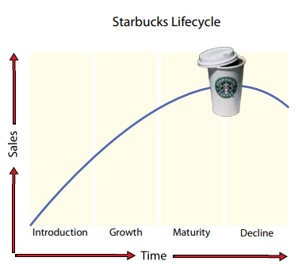

How we maintain at this point, we have to add some values that could maintain this.

The new product could be more **customer experience things.**

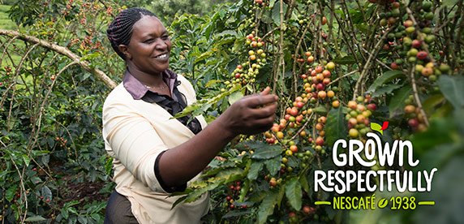 The propose product will be experience in **mobile app, live coffee making or campaign in “1 day with farmers experience”**

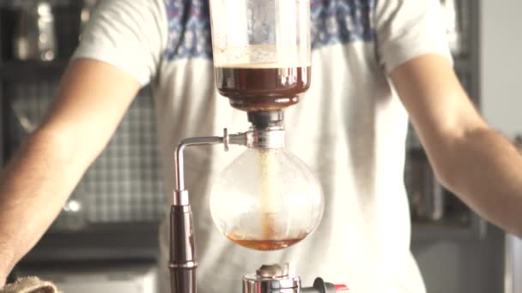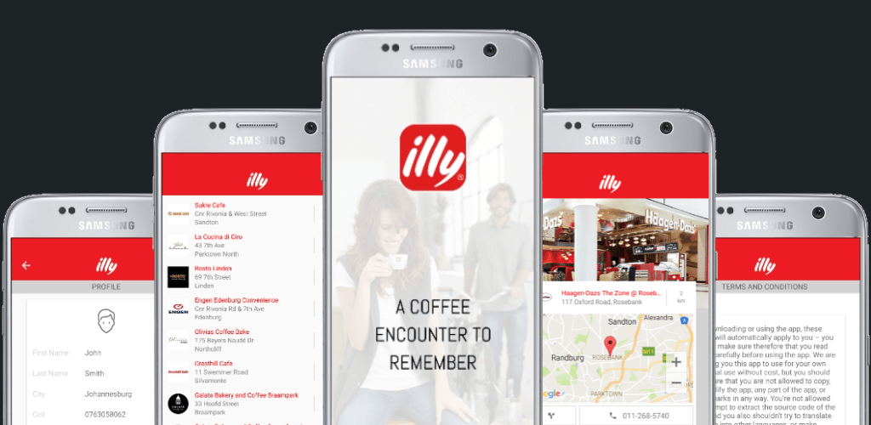

1. How do you propose the solution?. Which problem you prioritize the most? And Why? (Choose one and focus on that topic)

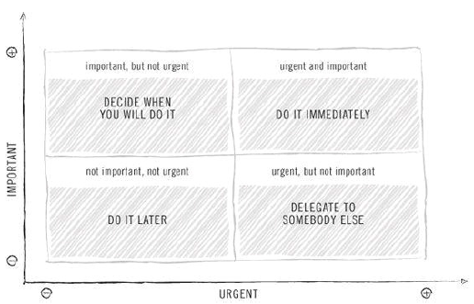

The solution is **Customers Experience on one cup of coffee**, choosing this solution could maintain our product on maturity level and educate customers to understand the value chain in one of coffee and making our product in next level.

**Reference:**

<https://www.fastcasual.com/articles/why-illy-caffe-north-america-coo-isnt-afraid-to-compete-with-starbucks/>

<https://www.uhu.es/45122/temas/P&SC/Theme1_StarbucksCoffe_CaseStudy.pdf>